TRACK 1 | Agentic AI for CYBERSECURITY
CyberSentinel: Multi-Agent Network Intrusion Detection & Adaptive Defense

Problem Statement
Build an agentic cybersecurity prototype that classifies network flows, identifies suspicious activity, combines evidence from multiple agents and applies explainable, simulated ALLOW/BLOCK policies. This is an offline traffic-replay challenge—not a live network attack or firewall deployment.

Dataset & Access
- Dataset: CICIDS2017 (labeled network-flow records). Training and labeled validation files will be shared in your respective WhatsApp group; use them for model development and testing.
- Five benchmark classes: BENIGN, BRUTE_FORCE, DOS, DDOS and PORT_SCAN. Original attack names will be mapped to these classes as specified with the dataset. Handle missing/infinite values and class imbalance appropriately.

DAY 1 | Level 1: Build Two Agents (30 October)
Agent | Required function / demonstrable output
1. Threat Detection Agent | Train a classifier to predict one of the five classes; report predicted class and confidence.
2.Anomaly Agent | Independently assess unusual flows.  Output: anomaly score and supporting feature evidence.
3. Evidence Fusion | Combine A1 and A2, including disagreements.  Output: final class, evidence status and rationale.

Day 1 Tasks & Submission
- Inspect and clean the training data.
- Train A1 and implement independent anomaly scoring in A2.
- Implement A3 and record how it handles agreement and disagreement.
- Run the complete pipeline on the official validation records.
- Report baseline accuracy, macro-F1 and a brief summary of the agents’ outputs.
- Submit Level 1 results through the API shared in the WhatsApp group by 8:00 PM. Day 1 requires an API summary submission; no final CSV upload is required.
- During the 6:00–8:00 PM slot, organizers will brief participants on Level 2. Teams may improve their models overnight; no live panel demonstration is required on Day 1.
IMPORTANT: Level 2 instructions are on the next page and will be shared during the Day 1 briefing.

TRACK 1 | CYBERSENTINEL — DAY 2 BRIEF
Level 2: Complete the Multi-Agent Detection & Defense System (31 October)
Keep A1–A3. Add TWO more agents to create one five-agent system.

Add Two More Agents
Agent | Required function / demonstrable output
4. Temporal Correlation Agent | Group related suspicious flows using observed endpoints and time windows. Output: group IDs, member records and supporting evidence.
5. Adaptive Defense Agent | Create temporary simulated ALLOW/BLOCK policies. Output: flow decisions, policy activation, scope and expiry logs.

Development & Hidden-Test Evaluation
- Replay official evaluation flows in chronological order.
- Apply already-active defense policies BEFORE analyzing a newly allowed flow.
- Use observed evidence to correlate suspicious flows and activate policies for later flows.
- Record every ALLOW/BLOCK action, policy ID, activation and expiry.
- Never use future records or hidden ground-truth labels to make a decision.
- Integrate all five agents in the following manner. Train/tune on training and labeled validation data. Demonstrate how the agents exchange evidence and influence the final action.
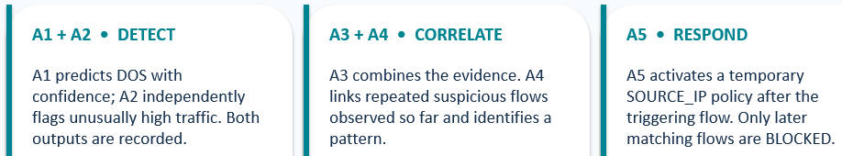

- At 1:30 PM, the organizers will release the common hidden test/replay data without class labels. Run the system in the supplied replay order; do not use hidden labels or future records to make decisions.

Final CSV Submission — Upload Three Files to API
File | Required columns
classification.csv | Predict all official hidden records from permitted flow features. Submit one five-class prediction per record, including flows later blocked during replay.  Columns: record_id, predicted_class, anomaly score, evidence status
policy.csv | Process the same records in the official order. At each record, apply earlier active policies first; if ALLOW, analyze it and possibly create a policy for LATER records.  Columns: policy_id, activated_after_record_id, scope_type, scope_value, expires_after_record_id, policy_action
replay.csv | policy_id, activated_after_record_id, scope_type, scope_value, expires_after_record_id

Use organizer-provided record IDs. For the scored interface, scope_type = SOURCE_IP, policy_action = BLOCK, and action = ALLOW or BLOCK. Policies apply only to later matching records while active. A BLOCK must reference a valid applicable policy; ALLOW has an empty applied_policy_id. Include every test record exactly once in classification.csv and replay.csv. Do not submit actual labels.
The final deadline, input files and API link will be announced in the WhatsApp group. The organizer API score is official; the panel may request a fresh replay to verify submitted outputs.

Final Live Demonstration
- Run your code before the panel. Show the working of all five agents, classification results, anomaly/evidence outputs, temporal correlation, consensus, policy activation/expiry and sample ALLOW/BLOCK decisions.
- Explain false positives, false blocks and the trade-off between attack containment and preserving benign traffic. Panel members will assess the implementation and evidence—not only the API score.

